J. P. Morgan, our esteemed relative

By D. A. Sharpe

[John Pierpont Morgan](https://www.britannica.com/biography/J-P-Morgan) (known best simply as J. P. Morgan) is my fourth cousin, three times removed.  The ancestor in common with us is [Samuel Spen](http://www.dasharpe.com/Genealogy/Charts/Morgan,JP.pdf)cer (1670 - 1756), my sixth great grandfather, and Morgan's third great grandfather.

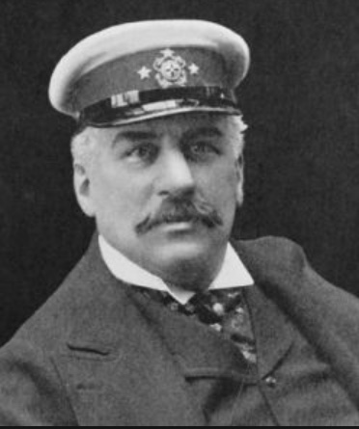John Pierpont Morgan was an American financier, banker, philanthropist, and art collector who dominated corporate finance and industrial consolidation during his time.  In 1892 Morgan arranged the merger of Edison [General Electric](https://en.wikipedia.org/wiki/General_Electric) and Thompson-Houston Electric Company to form General Electric.  After financing the creation of the Federal Steel Company, he merged the [Carnegie Steel Company](https://en.wikipedia.org/wiki/Carnegie_Steel_Company) and several other steel and iron businesses to form the [United States Steel Corporation](https://en.wikipedia.org/wiki/U.S._Steel) February 25, 1901, the year of my father’s birth.

J. P. Morgan is the 3rd great grandson of Samuel Spencer (1670 – 1756). Spencer had another 3rd great grandchild, Sarah Lavenna Kellogg, who married John Elsefer Sharp II, my great grandfather. Sarah gave birth to my father in 1901. The Spencer’s are a family that came to America in the 1600’s, with a strong tradition back to England with information in my records to the 1400’s, the earliest being John Spencer, my 12th great grandfather, (1482 – 1532), who lived and died in South Myles, Bedfordshire, England.

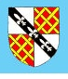Here’s the Spencer Family Crest:

[Here is a chart to show my relationship to J. P](http://www.dasharpe.com/Genealogy/Charts/Morgan,JP.pdf). Morgan.

Here’s my relationship to [Robert Spencer](http://www.dasharpe.com/Genealogy/Charts/Slpencer,%20Robert%2014th%20GG.pdf), my 14th great grandfather.

J. P. Morgan was born in Hartford, Connecticut to Junius Spencer Morgan (1813-1890) and Juliet Pierpont (1816-1884) of Boston, Massachusetts.  Pierpont, as he preferred to be known, had a varied education, due in part to interference by his father, Junius.  In the fall of 1848, Pierpont transferred to the Hartford Public School, and then to the [Episcopal Academy in Cheshire (now called Cheshire Academy](https://en.wikipedia.org/wiki/Cheshire_Academy)), boarding with the principal.  In September 1851, Morgan passed the entrance exam for [English High School of Boston](https://en.wikipedia.org/wiki/The_English_High_School), a school specializing in mathematics to prepare young men for careers in commerce.

In the spring of 1852, illness that was to become more common as his life progressed struck; rheumatic fever left him in so much pain that he could not walk.  Junius booked passage for Pierpont straight away on the ship owned by Charles Dabney, to the [Azores (Northern Portuguese islands](https://en.wikipedia.org/wiki/Azores)) for him to recover.  After convalescing for almost a year, Pierpont returned to the school in Boston to resume his studies.  After graduating, his father sent him to Bellerive, a school near the Swiss village of Vevey.  When Morgan had attained fluency in French, his father sent him to the [University of Göttingen](https://en.wikipedia.org/wiki/University_of_Göttingen) order to improve his German.  Attaining a passable level of German within six months, Morgan traveled back to London via Wiesbaden, his education complete.

Morgan entered banking in 1857 at his father's London branch, moving to New York City the next year, where he worked at the banking house of Duncan, Sherman & Company, the American representatives of George Peabody & Company.  From 1860 to 1864, as J. Pierpont Morgan & Company, he acted as agent in New York for his father's firm.  By 1864-72, he was a member of the firm of Dabney, Morgan & Company; in 1871, he partnered with the Drexel’s of Philadelphia to form the New York firm of Drexel, Morgan & Company.

During the War Between the States (the Civil War), Morgan was approached to finance the purchase of antiquated rifles being sold by the army for $3.50 each.  Morgan's partner re-machined them and sold the rifles back to the army for $22 each.  The military knew it was buying back its own guns, so the so-called 'scandal' turned out to be more about government inefficiency than any chicanery by Morgan (who never even saw the guns and acted only as a lender).  Morgan himself, like many wealthy persons, including future Democratic president Grover Cleveland, avoided military service by paying $300 for a substitute.

After the 1893 death of [Anthony Drexel](https://en.wikipedia.org/wiki/Anthony_Joseph_Drexel), the firm was re-christened J.P. Morgan & Company in 1895, and retained close ties with Drexel & Company of Philadelphia, Morgan, Harjes & Company of Paris, and J. S. Morgan & Company (after 1910 Morgan, Grenfell & Company), of London.  By 1900, it was one of the most powerful banking houses of the world, carrying through many deals especially reorganizations and consolidations.  Morgan had many partners over the years, such as George W. Perkins, but remained firmly in charge.

Morgan's ascent to power was accompanied by dramatic financial battles.  He wrested control of the [Albany and Susquehanna Railroad](https://en.wikipedia.org/wiki/Albany_and_Susquehanna_Railroad) from [Jay Gould](https://en.wikipedia.org/wiki/Jay_Gould) and [Jim Fisk](https://en.wikipedia.org/wiki/James_Fisk_%28financier%29) in 1869.  He led the syndicate that broke the government financing privileges of [Jay Cooke](https://en.wikipedia.org/wiki/Jay_Cooke), and soon became deeply involved in developing and financing a railroad empire by reorganizations and consolidations in all parts of the United States.

He raised large sums in Europe, but instead of only handling the funds, he helped the railroads reorganize and achieve greater efficiencies.  He fought against the speculators interested in speculative profits, and built a vision of an integrated transportation system.  In 1885, he reorganized the New York, West Shore & Buffalo Railroad, leasing it to the [New York Central](https://en.wikipedia.org/wiki/New_York_Central_Railroad).  In 1886, he reorganized the Philadelphia & Reading, and in 1888 the Chesapeake& Ohio.  He was heavily involved with railroad tycoon James J. Hill and the Great Northern Railway.

After Congress passed the Interstate Commerce Act in 1887, Morgan setup conferences in 1889 and 1890 that brought together railroad presidents to help the industry follow the new laws and write agreements for the maintenance of public, reasonable, uniform and stable rates.  The conferences were the first of their kind, and by creating a community of interest among competing lines, paved the way for the great consolidations of the early 20th century.

Morgan's process of taking over troubled businesses to reorganize them was known as *Morganization*.  Morgan reorganized business structures and management to return them to profitability.  His reputation as a banker and financier also helped bring interest from investors to the businesses he took over.

In 1895, at the depths of the Panic of 1893, the Federal Treasury was nearly out of gold.  [President Grover Cleveland](https://en.wikipedia.org/wiki/Grover_Cleveland) arranged for Morgan to create a private syndicate on Wall Street to supply the U.S. Treasury with $65 million in gold, half of it from Europe, to float a bond issue that restored the treasury surplus of $100 million.  The episode saved the Treasury, but hurt Cleveland with the agrarian wing of his Democratic party, and became an issue in the election of 1896, when banks came under withering attack from William Jennings Bryan.  Morgan and Wall Street bankers donated heavily to [Republican William McKinley](https://en.wikipedia.org/wiki/William_McKinley), who was elected in 1896 and reelected in 1900 on a gold standard platform.

In 1902, J. P. Morgan & Co. purchased the [Leyland line of Atlantic steamships](http://www.gjenvick.com/SteamshipLines/LeylandLine/index.html#axzz4ourSZxtU) and other British lines, creating an Atlantic shipping combine, the International Mercantile Marine Company, which eventually became the owner of [White Star Line](https://en.wikipedia.org/wiki/White_Star_Line), builder and operator of [RMS Titanic](https://en.wikipedia.org/wiki/RMS_Titanic).

After the death of his father in 1890, Morgan took control of J. S. Morgan & Co (re-named Morgan, Grenfell & Company in 1910). Morgan began talks with [Charles M. Schwab](https://en.wikipedia.org/wiki/Charles_M._Schwab), president of Carnegie Co., and businessman Andrew Carnegie in 1900 with the intention of buying Carnegie's business and several other steel and iron businesses to consolidate them to create the [United States Steel Corporation](https://en.wikipedia.org/wiki/U.S._Steel).  Carnegie agreed to sell the business to Morgan for $480 million.  The deal was closed without lawyers and without a written contract.  News of the industrial consolidation arrived at newspapers in mid-January 1901.  U.S. Steel was founded later that year and was the first billion-dollar company in the world with an authorized capitalization of $1.4 billion.

U.S. Steel aimed to achieve greater economies of scale, reduce transportation and resource costs, expand product lines, and improve distribution.  It was also planned to allow the United States to compete globally with Britain and Germany.  U.S. Steel's size was claimed by Schwab and others to allow the company to pursue distant international markets-globalization.  U.S. Steel was regarded as a monopoly by critics, as the business was attempting to dominate not only steel, but also the construction of bridges, ships, railroad cars and rails, wire, nails, and a host of other products.  With U.S. Steel, Morgan had captured two-thirds of the steel market, and Schwab was confident that the company would soon hold a 75 percent market share.  However, after 1901 the businesses' market share dropped; Schwab, himself, played an important role in falsifying his own prediction: finding the new company unwieldy, Schwab resigned from U.S. Steel in1903 to form Bethlehem Steel, which became the second largest U.S. producer on the strength of such innovations as the wide flange H beam, precursor to the I-beam widely used in construction.

Enemies of banking attacked Morgan for the terms of his loan of gold to the federal government in the 1895 crisis, for his financial resolution of the Panic of 1907, and for bringing on the financial ills of the New York, New Haven and Hartford Railroad.  In December1912, Morgan testified before the Pujo Committee, a subcommittee of the House Banking and Currency committee.  The committee ultimately found that a cabal of financial leaders were abusing their public trust to consolidate control over many industries:  the partners of J.P. Morgan & Co., along with the directors of First National and National City Bank, controlled aggregate resources of $22.245 billion.  Louis Brandeis, later a U.S. Supreme Court Justice, compared this sum to the value of all the property in the twenty-two states west of the Mississippi River.

In 1900, Morgan financed inventor Nikola Tesla and his Wardenclyffe Tower with $150,000 for experiments in radio. However, in 1903, when the tower structure was near completion, it was still not yet functional, due to last-minute design changes that introduced an unintentional defect.  When Morgan wanted to know Where can I put the meter? Tesla had no answer.  Tesla's vision of free power did not agree with Morgan's worldview; nor would it pay for the maintenance of the transmission system.  Construction costs eventually exceeded the money provided by Morgan, and additional financiers were reluctant to come forth.  By July 1904, Morgan (and the other investors) finally decided they would not provide any additional financing.  Morgan also advised other investors to avoid the project.

At the height of Morgan's career during the early 1900s, he and his partners controlled directly and indirectly assets worth $1.3 billion.

**Morgan was a lifelong member of the Episcopal Church, and by 1890 was one of its most influential leaders.**

In 1861, he married Amelia Sturges, known as Mimi (1835-1862).  After her death the next year, he married Frances Louisa Tracy, known as Fanny (1842 - 1924) on May 3, 1863.  They had four children.

He often had a tremendous physical effect on people; one man said that a visit from Morgan left him feeling 'as if a gale had blown through the House. Morgan was physically large with massive shoulders, piercing eyes and a purple nose, because of a chronic skin disease, rosacea.  His grotesquely deformed nose was due to a disease called rhinophyma, which can result from rosacea.  As the deformity worsens, pits, nodules, fissures, lobulations, and pedunculation contort the nose into grotesque cosmetic problems. This condition inspired the crude taunt ‘Johnny Morgan's nasal organ has a purple hue.'  Surgeons could have shaved away the rhinophymous growth of sebaceous tissue during Morgan's lifetime, but as a child Morgan suffered from infantile seizures, and it is suspected that he did not seek surgery for his nose, because he feared the seizures would return.

His social and professional self-confidence were too well established to be undermined by this affliction. It appeared as if he dared people to meet him squarely and not shrink from the sight, asserting the force of his character over the ugliness of his face.  He was known to dislike publicity and hated being photographed; because of his self-consciousness of his rosacea, all his professional portraits were retouched.

Morgan smoked dozens of cigars per day, and favored large Havana cigars dubbed Hercules' Clubs by observers.

His home on Madison Avenue was the first electrically lit private residence in New York.  His interest in the new technology was a result of his financing Thomas Edison's [Edison Electric Illuminating Company](https://en.wikipedia.org/wiki/Edison_Illuminating_Company) in 1878.  J. P. Morgan also owned [East Island in Glen Cove, NY](http://wikimapia.org/18696922/East-Island) where he had a large summer house.

J. P. Morgan's yacht, [Corsair](http://www.modelshipmaster.com/products/Super_yachts/morgan_yacht_corsair.htm), later bought by the U.S. Government and renamed the USS Gloucester to serve in the [Spanish-American War](http://www.history.com/topics/spanish-american-war). This is a War in which my grandfather, Henry (Harry) Seth Sharpe served in the United States Army, having been recruited by 1st Volunteer Cavalry Officer, Teddy Roosevelt (who is a 5th cousin to my half 8th cousin).   An avid yachtsman, Morgan owned several sizable yachts.

The well-known quote, 'If you have to ask the price, you can't afford it' is commonly attributed to Morgan in response to a question about the cost of maintaining a yacht, but the actual wording of the original statement is a bit obscure.

Morgan was scheduled to travel on the maiden voyage of RMS Titanic, but canceled at the last minute.  The Titanic was owned and operated by the White Star Line, and Morgan had his very own private suite and promenade deck on the ship.

Morgan died while traveling abroad in Rome. On March 31, 1913, just shy of his seventy-sixth birthday, Morgan died in his sleep at the Grand Hotel.  Nearly 4,000 condolence letters were received there overnight and flags on Wall Street flew at half-staff.  The stock market was also closed for two hours when his body passed through Wall Street.

At the time of his death, he had an estate worth $68.3 million ($1.39 billion in today's dollars), of which about $30 million represented his share in the New York and Philadelphia banks. The value of his art collection was estimated at $50 million. J. P. Morgan was bequeathed much of his large art collection to the Metropolitan Museum of Art in New York City and to the Wadsworth Atheneum of Hartford, Connecticut.  He died in Rome, Italy, in 1913 at the age of 75, leaving his fortune and business to his son, John Pierpont (Jack) Morgan, Jr.

His remains were interred in the Cedar Hill Cemetery in his birthplace of Hartford, Connecticut.  His son, J. P. Morgan, Jr., inherited the banking business.

Morgan was a notable collector of books, pictures, and, other art objects, many loaned or given to the Metropolitan Museum of Art (of which he was president and was a major force in its establishment), and many housed in his London house and in his private library on 36th Street, near Madison Avenue in New York City. His son, J. P. Morgan, Jr., made the Pierpont Morgan Library a public institution in 1924 as a memorial to his father, and kept [Belle da Costa Greene](https://en.wikipedia.org/wiki/Belle_da_Costa_Greene), his father's private librarian, as its first director.  Morgan was painted by many artists, including the Peruvian Baca Flor and the Swiss-born American Adolfo Muller-Ury, who also painted a double portrait of Morgan with his favorite grandchild, Mabel Satterlee, that for some years stood on an easel in the Satire mansion, but has now disappeared.

By the turn of the century J. P. Morgan had become one of America's most important collectors of gems and had assembled the most important gem collection in the U.S., as well as of American gemstones (over1,000 pieces).  Tiffany & Company assembled his first collection under their 'chief gemologist' George Frederick Kunz.  The collection was exhibited at the World's Fair in Paris in 1889.  The exhibit won two golden awards and drew the attention of important scholars, lapidaries and the public.

George Frederick Kunz then continued to build a second, even finer, collection which was exhibited in Paris in 1900.  Collections have been donated to the [American Museum of Natural History in New York](https://en.wikipedia.org/wiki/American_Museum_of_Natural_History) where they were known as the Morgan-Tiffany and the Morgan-Bement collections.   In 1911, Kunz named a newly found gem after his biggest customer: [Morganite](https://en.wikipedia.org/wiki/Beryl#Morganite).

Morgan was a benefactor of the American Museum of Natural History, the [Metropolitan Museum of Art](https://en.wikipedia.org/wiki/Metropolitan_Museum_of_Art), [Groton School](https://en.wikipedia.org/wiki/Groton_School), Trinity College, the [Lying-in Hospital of the City of New York](https://en.wikipedia.org/wiki/Society_for_the_Lying-In_Hospital), the New York trade schools. and [Harvard University (especially its medical school)](https://en.wikipedia.org/wiki/History_of_Harvard_University). Our family connection with Harvard is that [Howard Pelham](http://www.dasharpe.com/Genealogy/Charts/Pelham,HerbertChart%20.pdf), its first Treasurer, was the 2nd great grandnephew of the wife of the 3rd cousin, 5 times removed from the husband of the stepdaughter of my 6th great granduncle.

Morgan was also a patron to photographer Edward S. Curtis, offering Curtis $75,000 in 1906, for a series on the Native Americans.  Curtis eventually published a 20-volume work entitled, 'The North American Indian.'  Curtis went on to produce in 1914 a motion picture, “In The Land Of The Head Hunters,” which was later restored in 1974 and re-released as 'In The Land Of The War Canoes.'  Curtis was also famous for a 1911 Magic Lantern slide show, 'The Indian Picture Opera,' which used his photos and original musical compositions by composer Henry F. Gilbert.

His son, J. P. Morgan, Jr. took over the business at his father's death, but was never as influential.  As required by the 1933 Glass-Steagall Act, the 'House of Morgan' became three entities:  J. P. Morgan and Co., and its bank, Morgan Guaranty Trust; Morgan Stanley, an investment house; and Morgan Grenfell in London, an overseas securities house.

There is now a restaurant in [Montpelier, Verm](http://www.montpelier-vt.org/)ont named after J. P. Morgan, the gemstone Morganite was named in his honor.

In his satirical history of the United States, ['It All Started with Columbus](http://www.goodreads.com/book/show/1033518.It_All_Started_with_Columbus),' Richard Armour commented that 'Morgan, who was a direct sort of person, made his money in money ...  He became immensely wealthy because of his financial interests, most of which were around eight or ten percent ... This Morgan is usually spoken of as J.P. to distinguish him from [Henry Morgan, the pirate](https://en.wikipedia.org/wiki/Henry_Morgan).'

Bertolt Brecht, the German writer, based the figure of Pierpont Mauler the beef tycoon in his [play Saint Joan of the Stockyards](https://en.wikipedia.org/wiki/Saint_Joan_of_the_Stockyards), on Morgan.

In the musical ['How to Succeed in Business Without Really Trying](https://en.wikipedia.org/wiki/How_to_Succeed_in_Business_Without_Really_Trying), 'the character J. Pierrepont Finch is portrayed as a rising, powerful businessman; his character is possibly an allegory of Morgan's.  The character Mr. Bratt alludes to the nominal similarity in the beginning of the show: 'Pierrepont. Say, maybe that ought to be J. Pierrepont Finch.'

J. P. Morgan appears in [E. L. Doctorow's novel “Ragtime](https://en.wikipedia.org/wiki/Ragtime_(novel)),” and in the Broadway musical inspired by it of the same name.

J.P. Morgan is mentioned, by name, by Oliver Warbucks in the [Broadway musical, 'Annie.'](https://en.wikipedia.org/wiki/Annie_(musical))

J.P. Morgan is mentioned in F. Scott Fitzgerald's famous novel, ['The Great Gatsby](https://en.wikipedia.org/wiki/The_Great_Gatsby).'

J.P. Morgan is also mentioned in John Steinbeck's novel, ['The Grapes of Wra](https://en.wikipedia.org/wiki/The_Grapes_of_Wrath)th.'

The name J.P. Morgan is mentioned in the song 'We Got Elegance' in the Jerry Herman [musical 'Hello, Dolly!](https://en.wikipedia.org/wiki/Hello,_Dolly!_(musical))'

Carlito Brigante is likened to J. P. Morgan in the [1993 film 'Carlito's Wa](https://en.wikipedia.org/wiki/Carlito%27s_Way)y.'

J.P. Morgan is also mentioned in the novel ['Against the Day,' by Thomas Pynchon.](https://en.wikipedia.org/wiki/Against_the_Day)

A satirical version of J. P. Morgan appears in Matt Fraction and Steven Sanders' graphic novel, 'The Five Fists of Science.'

In ['The Wind and the Lio](https://en.wikipedia.org/wiki/The_Wind_and_the_Lion)n,' Theodore Roosevelt mockingly toasts Morgan and refers to him as (aside from the Raisuli) 'the only real pirate I know.'  [[Theodore is the fifth cousin to Franklin Delano Roosevelt, my half eighth cousin](http://www.dasharpe.com/Genealogy/Charts/Roosevelt,-TEDDY.pdf)]

The source for much of this information is: <http://en.wikipedia.org/wiki/J._P._Morgan>

The Chase Manhattan Bank until it merged with J.P. Morgan & Co. in the year, 2000. Chase Manhattan Bank was formed by the merger of the Chase National Bank and The Manhattan Company in 1955. The bank has been headquartered in Columbus, Ohio since its merger with BankOne Corporation in 2004.

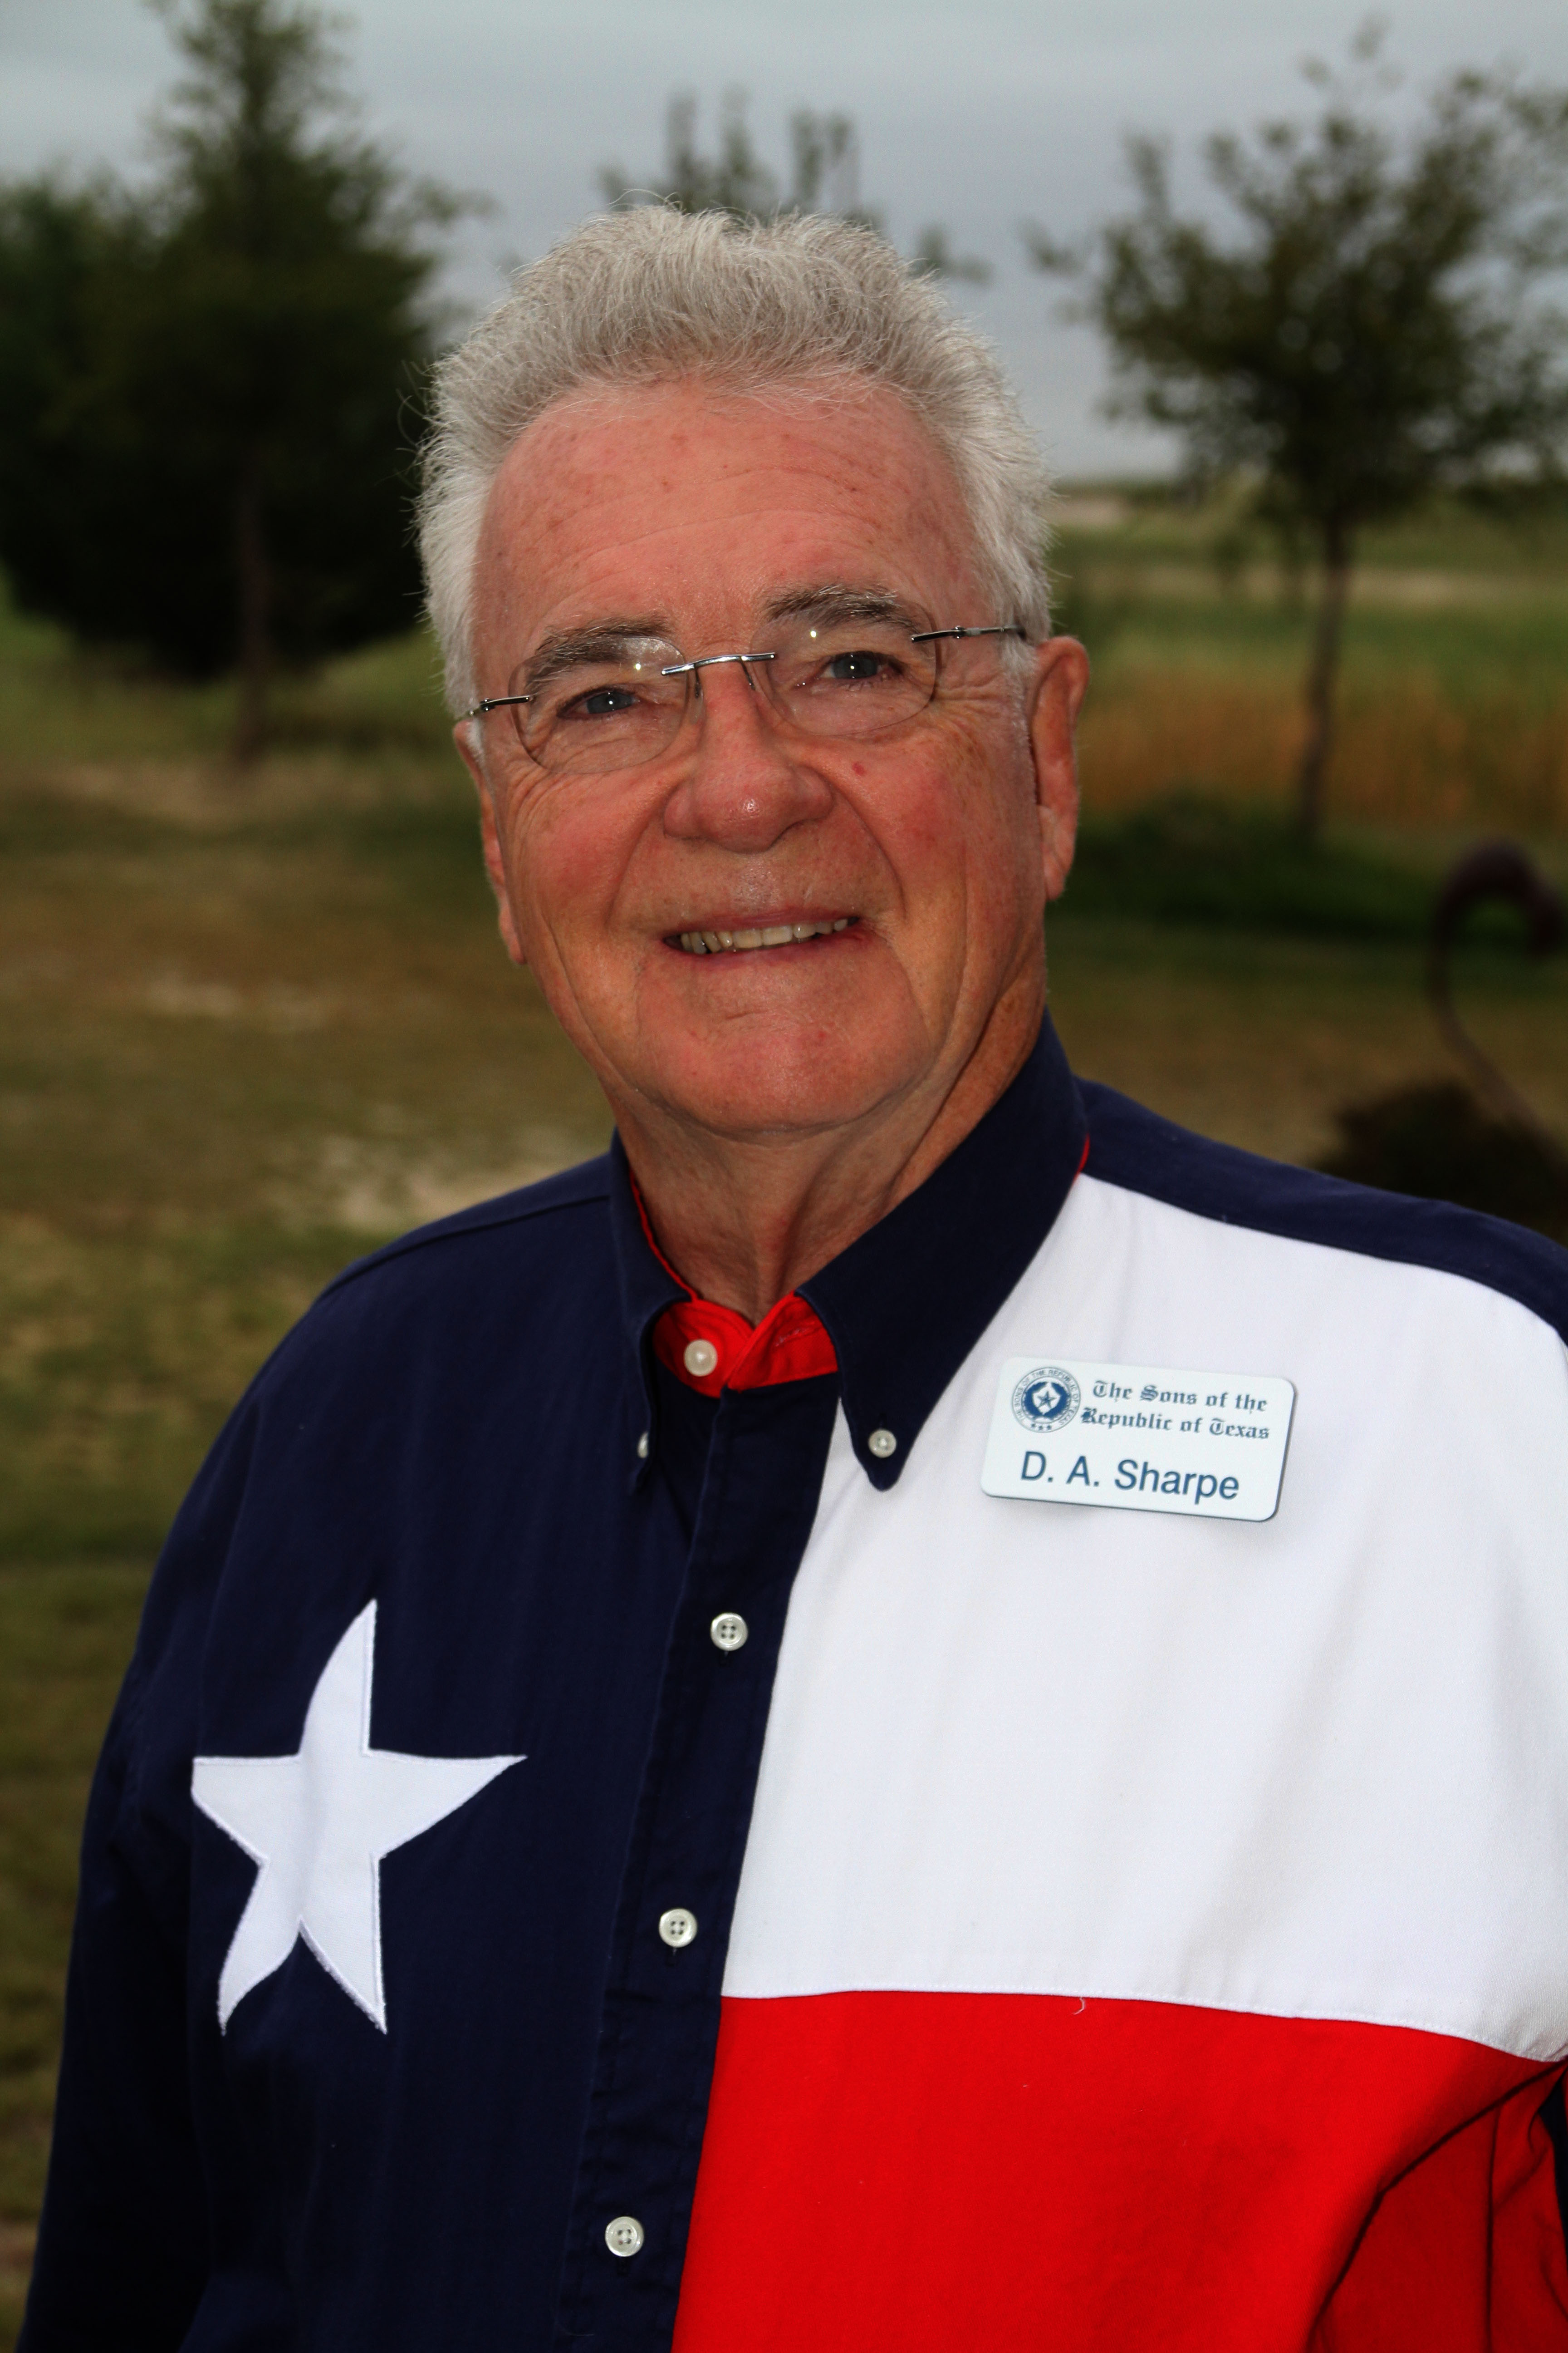I’m pleased to say that in 2017, there was occasion for Suzanne and me to change banks, and our new accounts are at the Chase Bank! It’s fun and comforting to think that our bank is so much in our family!

Dwight Albert (D. A.) Sharpe

805 Derting Road East

Aurora (Wise County), Texas 76078-3712

[da@dasharpe.com](mailto:da@dasharpe.com)

[www.dasharpe.com](http://www.dasharpe.com)

Facebook: [Dwight Albert Sharpe](https://www.facebook.com/dasharpe)

[Biographical Sketch Information](http://www.dasharpe.com/Bioskets/BiographicalHome.htm)

Below is a current article about our family bank!



